**Registrar-Alangilan Campus**

Batangas State University –

The National Engineering University

Golden Country Homes

Alangilan, Batangas City

Dear Sir/Ma’am:

This letter is to inform you that I give permission to **Kitz Adam F. Maligalig** an architecture student of Batangas State University to claim, sign, pay, and receive on my behalf any documents or transaction process regarding my request for Diploma and Transcript of Records. Affixed in this letter are my signature of authorization and my valid IDs.

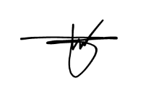Sincerely,

**Tyronne F. Mago**

Pili, Pinamalayan.

Oriental Mindoro

09481482034

tyronmago@gmai.com

